**SPRINT-5 YOLO MODEL for Stamp verification:**

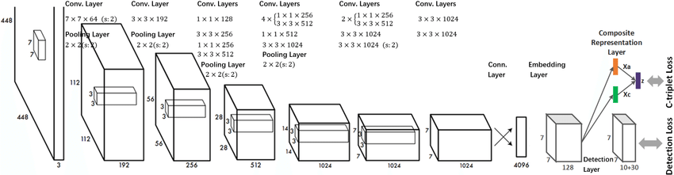

 YOLO divides each image into a grid of S x S and each grid predicts N bounding boxes and confidence. The confidence reflects the accuracy of the bounding box and whether the bounding box actually contains an object(regardless of class). YOLO also predicts the classification score for each box for every class in training. You can combine both the classes to calculate the probability of each class being present in a predicted box.

**Requirements and setup:**

First of all we need to install a couple of packages and download some more from GitHub

1) TensorFlow ( Install using pip )

2) DarkFlow – TensorFlow adaptation of Darknet network runner

3) Some configuration and weight files

1. Installing TensorFlow Install TensorFlow using PIP :

**$ sudo pip install tensorflow**

2. Installing DarkFlow

DarkFlow is a network builder adapted from Darknet, it allows building TensorFlow networks from cfg files and loading pre trained weights. We will use it to run YOLO.

a. Clone DarkFlow from : <https://github.com/thtrieu/darkflow>

b. Weights and cfg files can be found on : https://pjreddie.com/darknet/yolo/

c. We will use Tiny-Yolo: (Last One)

d. Download cfg and weights file and copy them to the DarkFlow folder

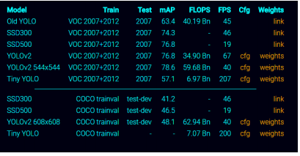

Setup the configuration and weights

1. Download the weights file

2. Download the configuration file

**Getting started**

You can choose one of the following three ways to get started with darkflow.

1. Just build the Cython extensions in place.

**python3 setup.py build_ext --inplace**

1. Let pip install darkflow globally in dev mode (still globally accessible, but changes to the code immediately take effect)

**pip install -e .**

1. Install with pip globally

**pip install .**

**Clone Or Download Repository**

<https://github.com/thtrieu/darkflow>

### Training on your own dataset

The steps below assume we want to use tiny YOLO and our dataset has 3 classes

1. Create a copy of the configuration file tiny-yolo-voc.cfg and rename it according to your preference tiny-yolo-voc-3c.cfg (It is crucial that you leave the original tiny-yolo-voc.cfg file unchanged, see below for explanation).
2. In tiny-yolo-voc-3c.cfg, change classes in the [region] layer (the last layer) to the number of classes you are going to train for. In our case, classes are set to 3.
3. ...

**[region]**

**anchors = 1.08,1.19, 3.42,4.41, 6.63,11.38, 9.42,5.11, 16.62,10.52**

**bias_match=1**

**classes=3**

**coords=4**

**num=5**

**softmax=1**

...

1. In tiny-yolo-voc-3c.cfg, change filters in the [convolutional] layer (the second to last layer) to num * (classes + 5). In our case, num is 5 and classes are 3 so 5 * (3 + 5) = 40 therefore filters are set to 40.

[**convolutional]**

**size=1**

**stride=1**

**pad=1**

**filters=40**

**activation=linear**

**[region]**

**anchors = 1.08,1.19, 3.42,4.41, 6.63,11.38, 9.42,5.11, 16.62,10.52**

...

Change labels.txt to include the label(s) you want to train on (number of labels should be the same as the number of classes you set in tiny-yolo-voc-3c.cfg file). In our case, labels.txt will contain 3 labels.

**label1**

**label2**

**label3**

1. Reference the tiny-yolo-voc-3c.cfg model when you train.

**flow --model /home/ubuntu/Music/YOLO_WAJIHA/darkflow-master-1/darkflow-master/cfg** **tiny-yolo-voc-1c.cfg --load bin/** **yolov2-tiny-voc.weights --train --annotation /home/ubuntu/Music/YOLO_WAJIHA/darkflow-master-1/darkflow-master/images/train --dataset /home/ubuntu/Music/YOLO_WAJIHA/darkflow-master-1/darkflow-master/images/train**

**OUTPUT:**

**After training the model getting the loss as 105.**